The S3 bucket is visible in the AWS Management console:

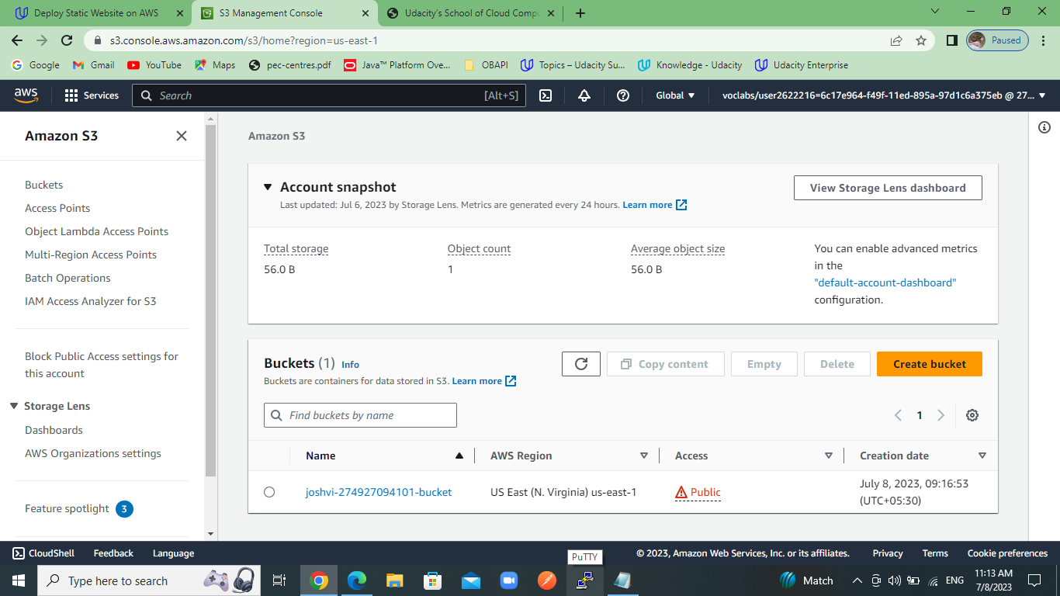

Submitted a screenshot showing all the website files uploaded to the newly created S3 bucket.

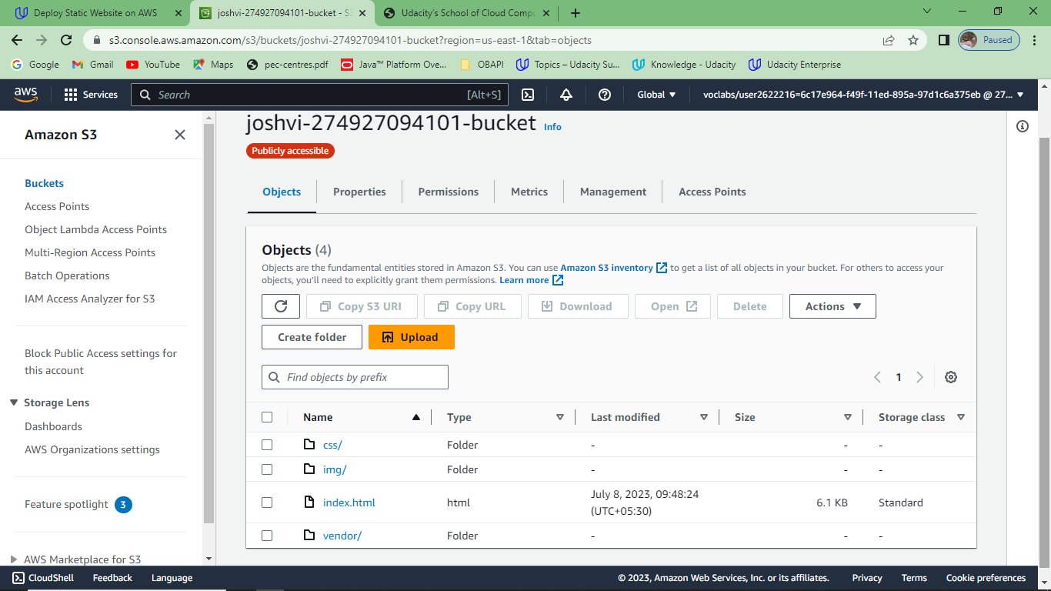

The S3 bucket is configured to support static website hosting.:

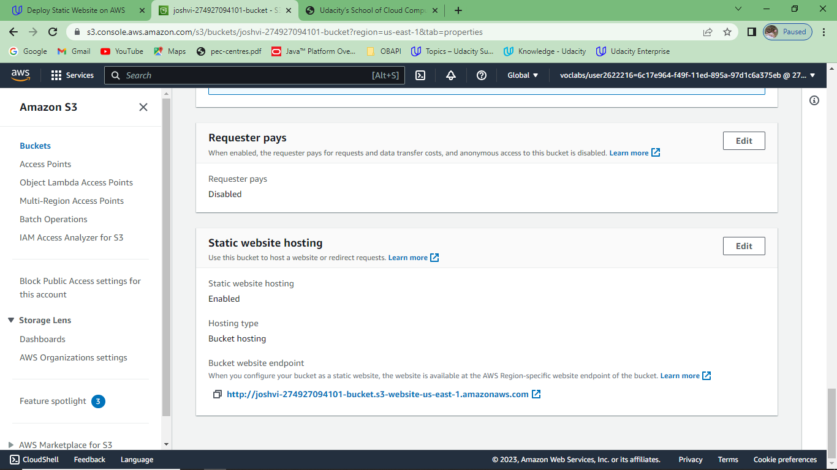

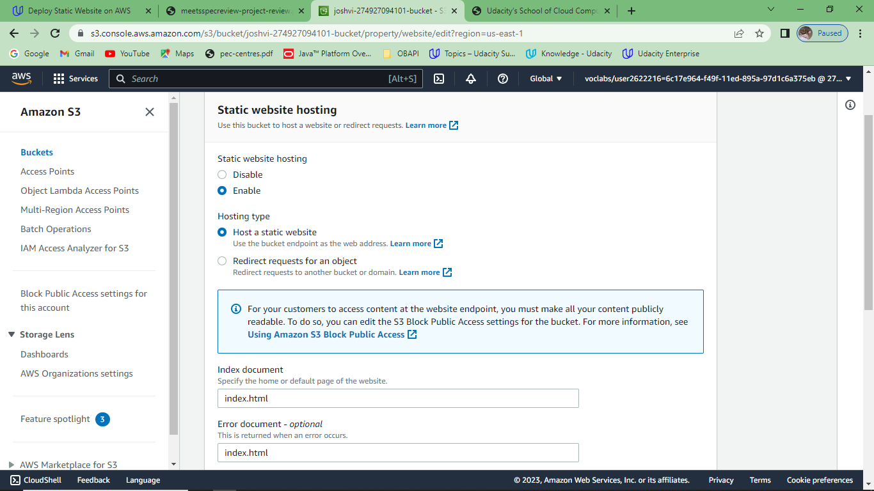

The S3 bucket has an IAM bucket policy that makes the bucket contents publicly accessible.

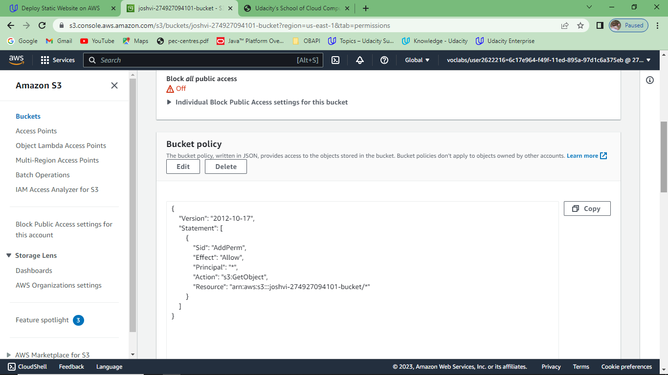

CloudFront has been configured to retrieve and distribute website files:

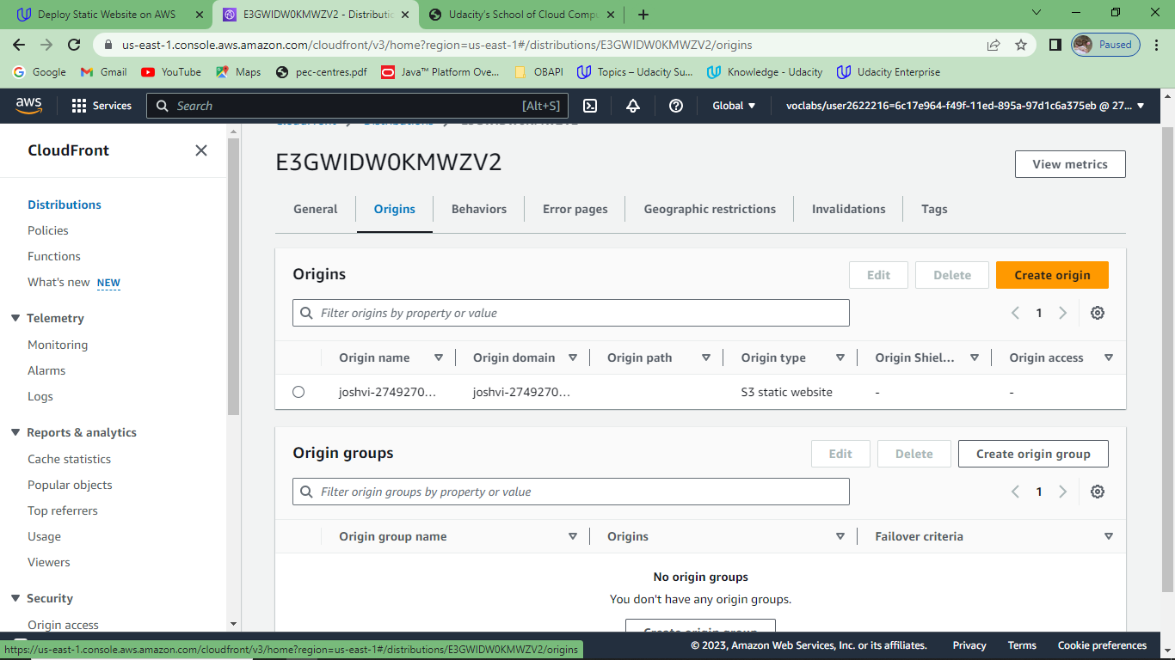

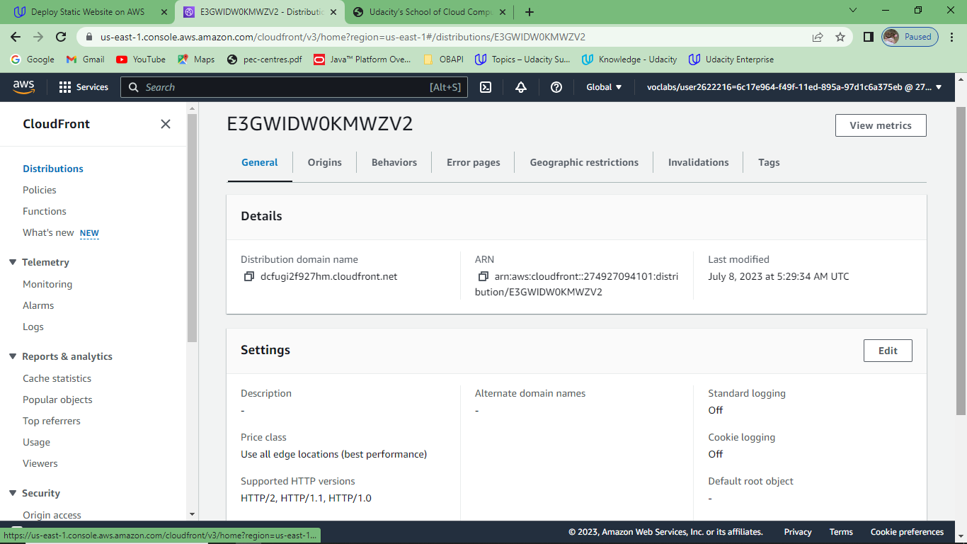

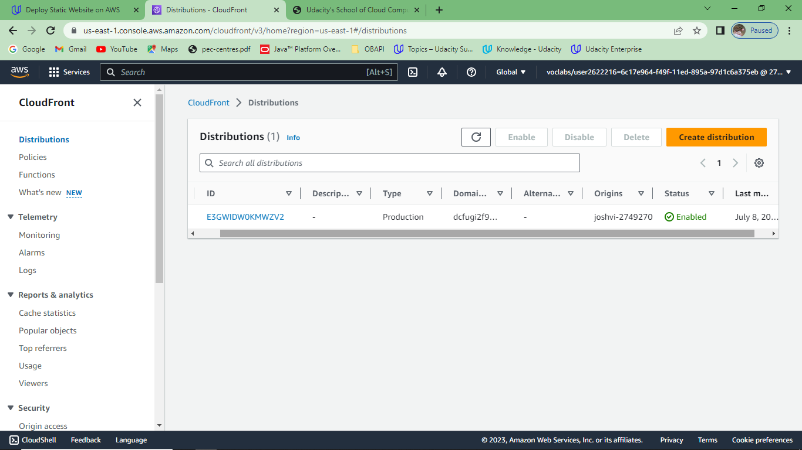

CloudFront domain name URL:



website-endpoint URL:

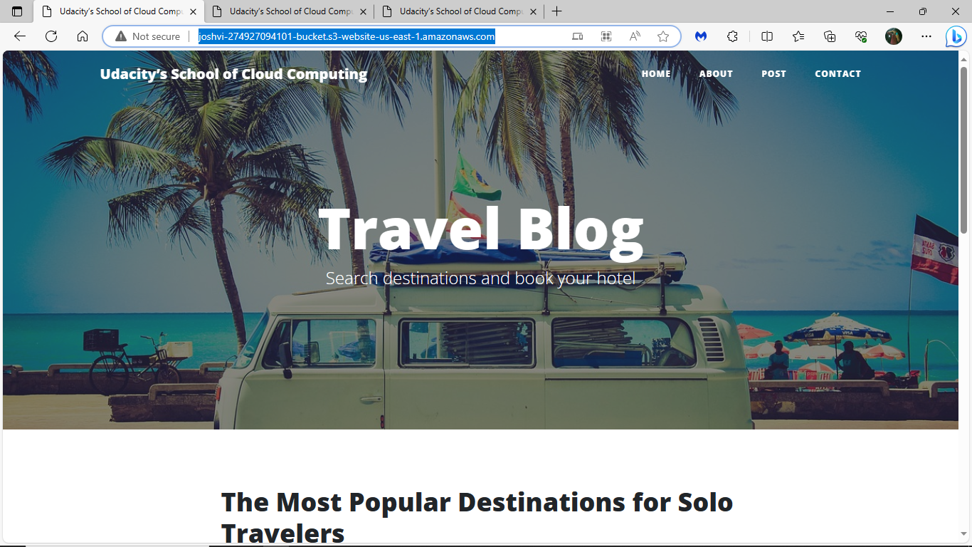

S3 Object Access:

